1. Go To –  
    <https://git-scm.com/downloads>
2. Click on “**Windows**” button.

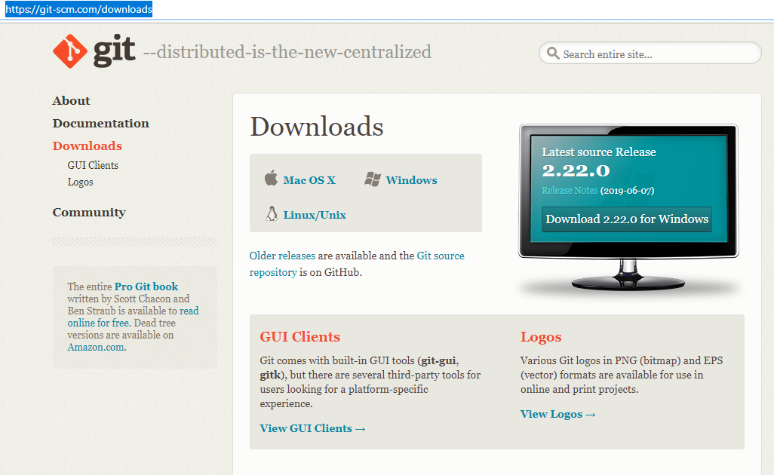

1. It will start downloading latest version of Git automatically.

Once the download is completed, **run** the downloaded **.exe** file-

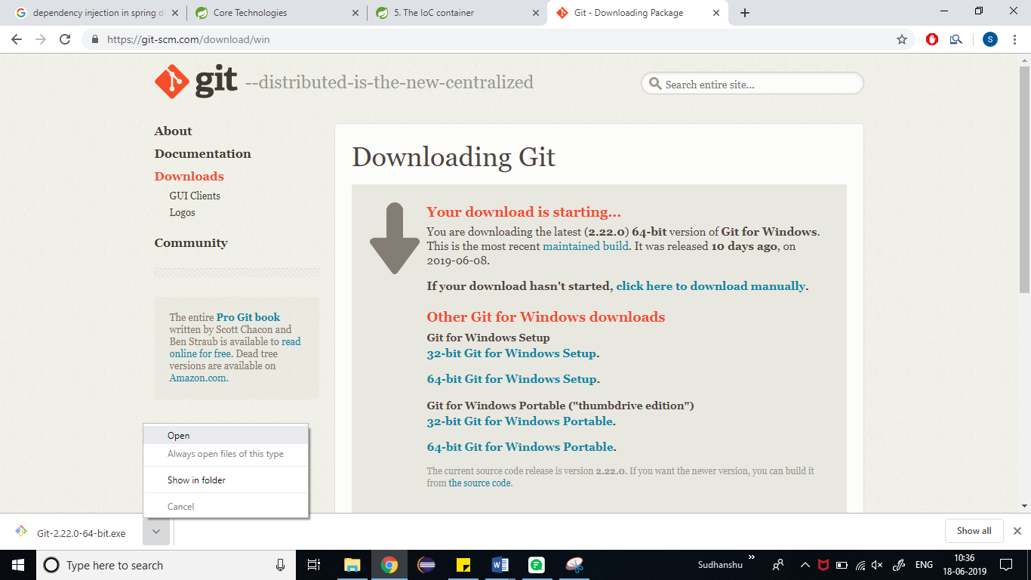

1. Click on **Next** –

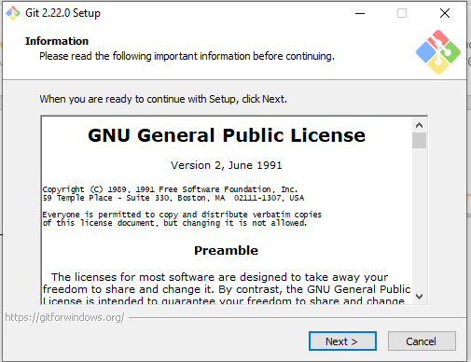

1. Install it in C:\Program Files\Git, click on **Next** –

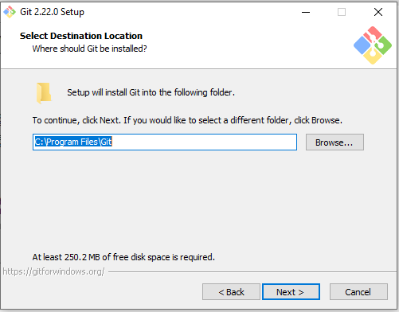

1. Click on **Next** –

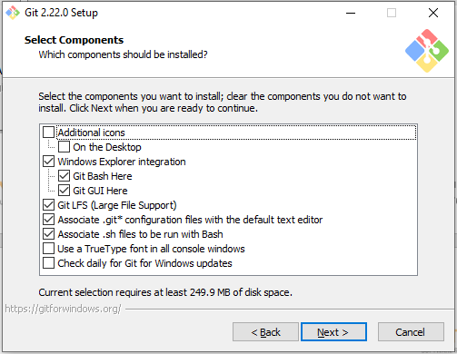

1. Click on Next –

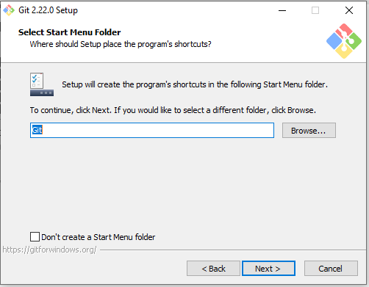

1. Click on Next –

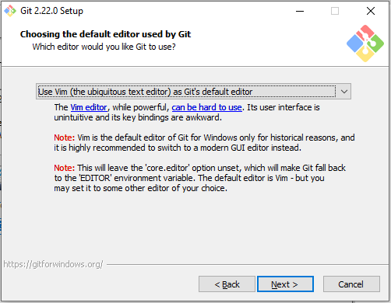

1. Click on Next –

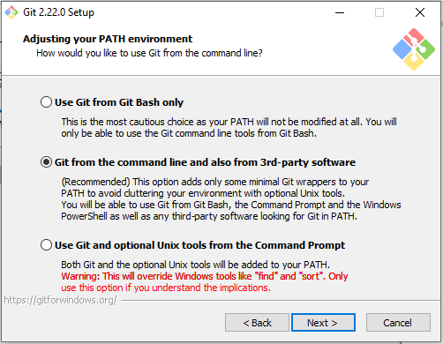

1. Click on **Next** –

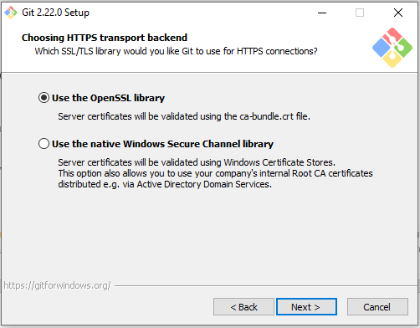

1. Click on **Next** –

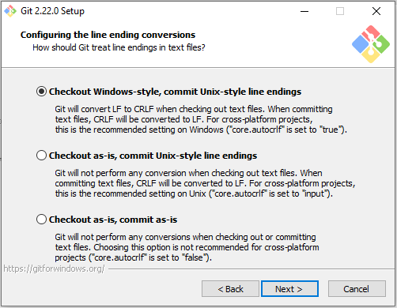

1. 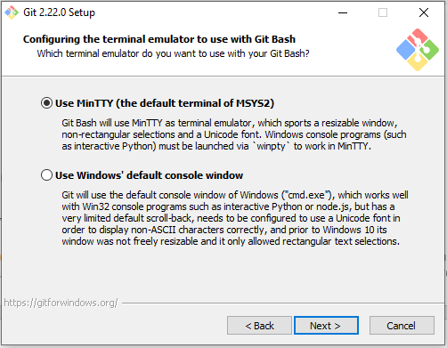Click on **Next** –
2. Click on **Next** –

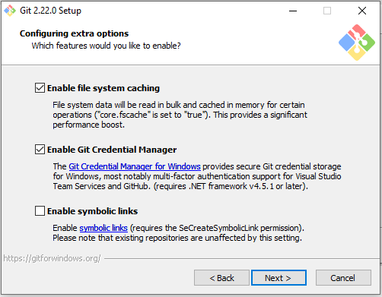

1. Click on **Install** –

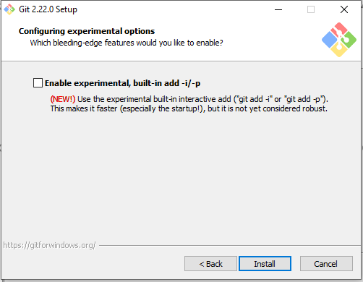

1. *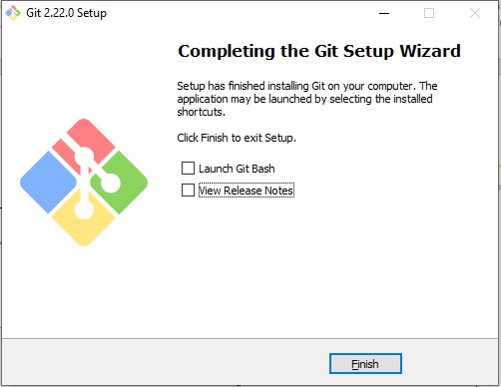Uncheck all check boxes* and Click on **Finish** –